Warm Up:
- List your thoughts for both sides of the argument: Should phones be allowed in school?
- Record as many thoughts, examples, details that you can think of. This is just a brainstorm activity.
Yes | No

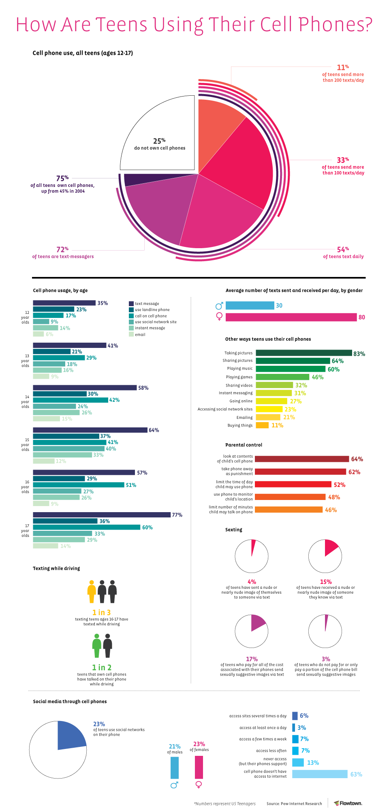
Find Evidence
- Record one piece of evidence from the chart to support each side of the argument:
Yes, phones should be allowed in school. | No, phones should not be allowed in school.

Gather more evidence:
- Use the chart above and the following articles:
  - Chart: https://www.communicationstudies.com/teen-cell-phone-statistics-infographic#:~:text=Through%20the%20infographic%20we%20find,than%20200%20texts%20per%20day.&text=23%20percent%20of%20teenagers%20use,no%20mobile%20access%20to%20internet.
  - Text #1: https://www.usatoday.com/story/tech/2020/02/05/should-kids-have-cellphones-at-school/4669488002/
  - Text #2: https://www.oxfordlearning.com/should-cell-phones-be-allowed-classrooms/
Yes, phones should be allowed in school. | No, phones should not be allowed in school.
Reflect:
- Should cellphones be allowed in school?
  - Clearly state your opinion
  - Provide at least 3 pieces of evidence that support your opinion.
  - Clearly explain each piece of evidence and how it relates to your opinion.

